|  |  |
| --- | --- |
| DOCUMENTATION FILE | tEAM kARMA  NIT RAIPUR  Pushkar kumar  shreyansh srivastava  ankur srivatava |

**INTERNAL COMBUSTION ENGINE**

**Global market analysis**

The global internal combustion engine market size was USD 147.0 Billion in 2022 and is expected to reach USD 228.05 Billion in 2032, and register a revenue CAGR of 5% during the forecast period.

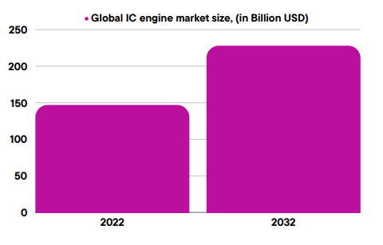

**Top 5 Automobile Industry**

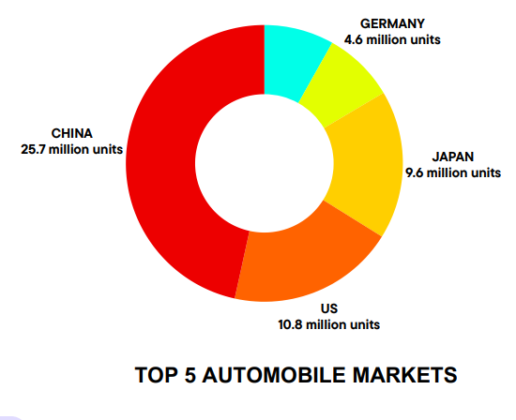

1. **China** :- **In 2019,** [**China**](https://ins-globalconsulting.com/countries/china/peo/) **produced more than 26 million automobiles, which makes up 28% of total worldwide automobile productions.**83% of China’s total production went into building personal passenger vehicles while the remaining 17% was towards vehicles for commercial use. **China has pledged to become carbon neutral by 2060.**

**2. USA:-** [**The United States**](https://ins-globalconsulting.com/countries/us/employer-of-record/) **continued to stay strong as the second-largest automobile manufacturer at 12% of the total global market share.** [The United States](https://ins-globalconsulting.com/countries/us/employer-of-record/) hasnet-zero emissions by 2050.

**3.Japan:-** [Japan](https://ins-globalconsulting.com/countries/japan/peo/) is the world’s third-largest total automobile producing nation in the world at roughly 9.6 million units. In terms of personal vehicles, Japan ranks second only behind China. Japan is among a group of 136 countries that have pledged climate commitments to reach net zero by 2050.

**4.Germany: -** [**Germany**](https://ins-globalconsulting.com/countries/germany/peo) **is the fourth biggest vehicle manufacturer worldwide in 2019 producing 4.7 million vehicles.** Germany, Europe's biggest emitter of greenhouse gases, plans to hit net zero emissions by 2045.

**5. India:-** [**India**](https://ins-globalconsulting.com/countries/india/peo/) **is the world’s fifth-largest automotive manufacturer producing 4.5 million vehicles in 2019.** 80% of India-produced vehicles were passenger cars, while 20% were commercial vehicles. India is committed to achieve the Net Zero emission target by 2070.

**LIGHT** **DUTY VEHICLE (LDV)**

The Light Duty vehicle Market was valued at USD 724.28 Bn in 2022 to reach USD 1380.83 Bn by 2030 with a forecasted CAGR of around 8.4%.

**HEAVY DUTY VEHICLE (HDV)**

The **Heavy-Duty vehicle Market**, valued at USD 204.56 billion in 2022 to reach **USD 313.95 billion** in 2027 with a forecasted CAGR of around **7.4%** .

**IC Engine Vehicle Market Leaders**

1.Honda Motors 2. Volkswagen

3.AG Toyota 4. Hyundai Motors

5. **Kirloskar Oil Engines Ltd**

**Why are IC engine vehicle widely used?**

Internal Combustion Engines (ICE) are widely used for several reasons:

1. Proven Technology: - ICE technology has been developed and refined over more than a century, making it a well-established and proven method of propulsion.

2. Energy Density: - Fossil fuels used in ICE, such as gasoline and diesel, have high energy density, providing a significant amount of energy per unit of volume.

3. Infrastructure: - The existing infrastructure, including fueling stations and repair facilities, is well-established for traditional internal combustion engines.

4. Range and Refueling Time:- ICE vehicles typically offer longer driving ranges and quicker refueling times compared to some alternative propulsion technologies, making them convenient for many users.

5. Versatility:- Internal combustion engines are versatile and can be used in various vehicle types, including cars, trucks, motorcycles, and more.

6. Cost:- ICE vehicles have historically been more affordable to produce, purchase, and maintain compared to certain alternative technologies.

**Impact Of IC Engine on Nature**

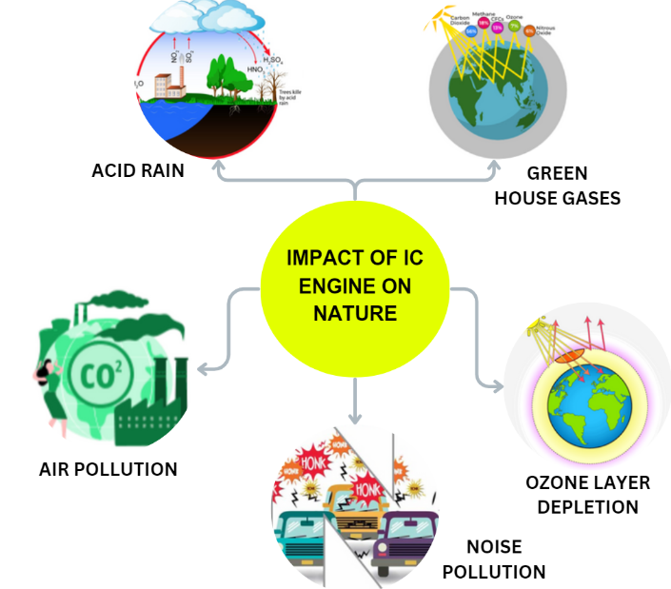

**Conventional vs Alternatives Vehicles**

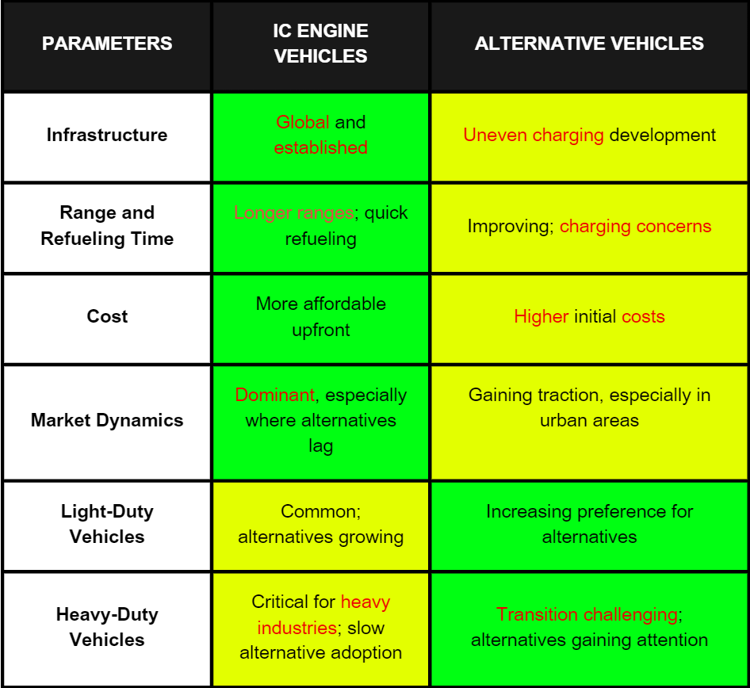

**IC engines persist** due to infrastructure, versatility, innovation, and cost benefits. **Light Duty vehicle endure till 2040**, heavy-duty vehicles**(transportation)** remain **relevant until 2060**.

**Casting Processes**

.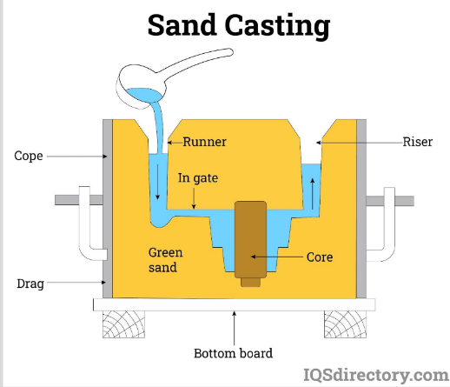

1.Sand casting is a metal casting process using sand moulds. Molten metal is poured into the , forming the desired shape.

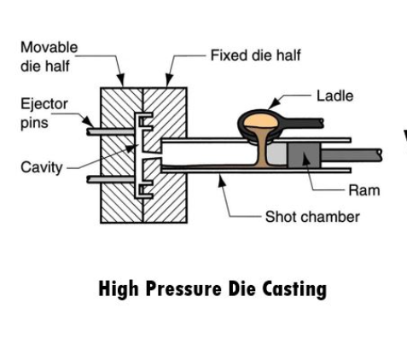

2.High-Pressure Die Casting (HPDC) is a metal casting process using high pressure to inject molten metal into intricate moulds.

**What are the major components of IC engine formed by casting?**

1. Engine Block 2. Cylinder Head

3. Crankcase 4. Pistons

5. Connecting Rods 6. Camshaft

7. Intake and Exhaust Manifolds

**Vehicle weight, size, and fuel consumption**

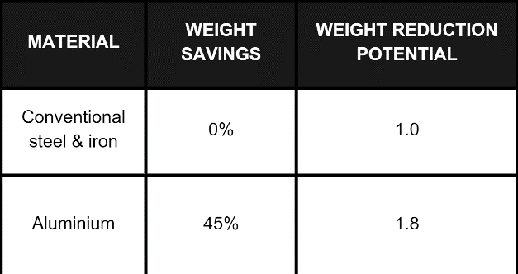

Vehicle weight, size, and fuel consumption are all intimately connected. A vehicle with a significantly lower weight will consume significantly less energy per kilometre. travelled. Aluminium engine blocks weighs half as much as iron blocks .

**High-Pressure Die Casting (HPDC) VS Sand Casting**

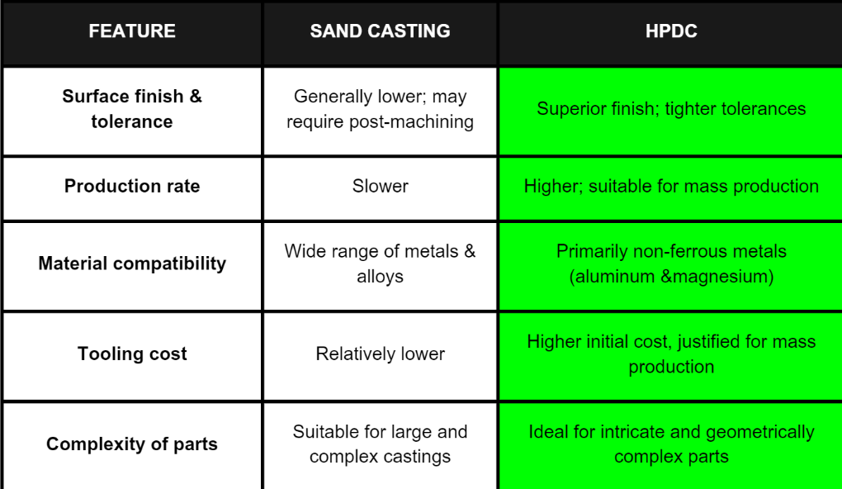

HPDC is favored for its efficiency, precision, and suitability for **mass production** especially in the manufacturing of **lightweight** components like **aluminium engine blocks**.

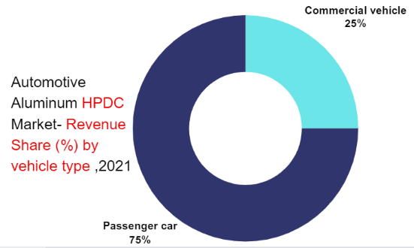

With rising sales of the passenger car segment demand for HPDC is witnessing promising growth. Nowadays, passenger car demand. HPDC in their different car components owing to their lightweight features and higher tensile strength.

**Other automotive parts formed by HPDC**

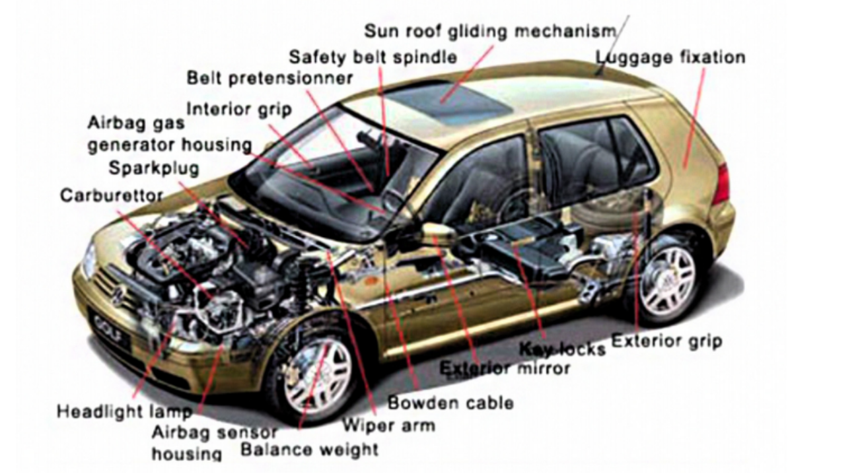

**NAVIGATING THE CNG LANDSCAPE**

**Global Market Analysis**

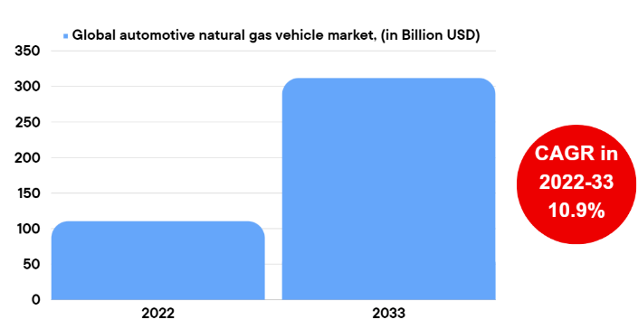

The global Automotive Natural Gas Vehicle Market is expected to reach USD 312 Billion by 2032, at a CAGR of 10.9% during the forecast period 2022 to 2032.

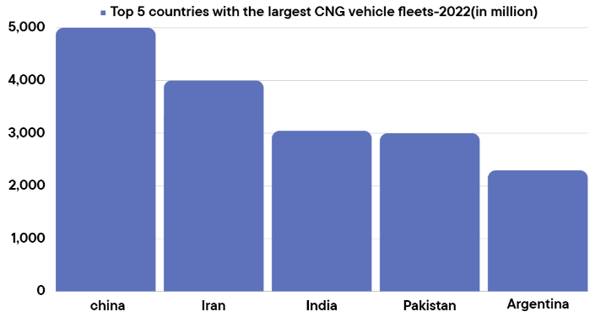

China have the highest number of CNG run vehicles in the world. Natural gas vehicles are increasingly used in Iran, Pakistan, the Asia-Pacific region, the Indian capital of Delhi, and other large cities such as Ahmedabad, Mumbai, Pune, and Kolkata.

The CNG fuel is mostly used by taxi drivers because of its much lower price compared to petrol.

**CNG Vehicle Market Leaders**

1.General Motors 2. Volkswagen AG

3.Honda Motor Company 4.Toyota Motor

**Jeevan Foundry's Strategic Moves Towards modified CNG engines Technology**

1. Diversification of Casting Processes:-Integrate High-Pressure Die Casting (HPDC) for lightweight and efficient CNG engine components, ensuring precision and cost-effectiveness.

2. R&D for CNG-specific Alloys:-Invest in research and development to formulate alloys tailored for CNG engines, focusing on durability, thermal conductivity, and corrosion resistance.

3. Customized Component Solutions:-Offer bespoke casting solutions for CNG engine parts, catering to diverse vehicle types, enhancing performance, and adhering to stringent industry standards.

4. Training and Skill Development :-Establish training programs for workforce skill enhancement in HPDC technology, ensuring proficiency in casting processes relevant to the CNG vehicle market.

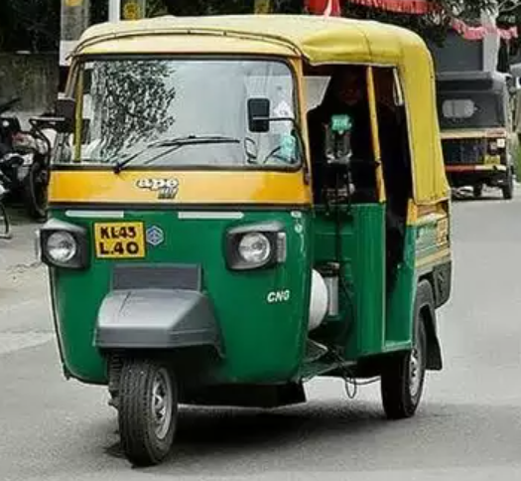

Global Trends & Scopes Revolutionizing the Hydrogen Combustion Engine Market

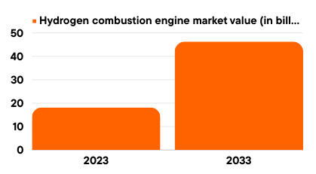

The market value of hydrogen combustion engines reached USD 18.22 billion in 2023 and is projected to grow at a Compound Annual Growth Rate (CAGR) of 9.78%, reaching USD 46.31 billion by 2033. This significant expansion underscores the increasing prominence and adoption of hydrogen-powered combustion engines in the market.

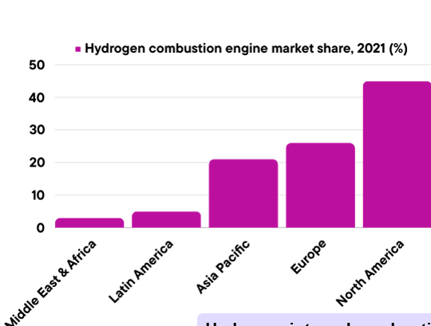

North America stands as the world's largest market for hydrogen combustion engines, reflecting its leadership in adopting and driving the growth of this technology, contributing significantly to the global expansion of hydrogen-powered engine solutions.

TOP MARKET PLAYERS OF THE HYDROGEN COMBUSTION ENGINE MARKET

* Volvo AB
* Toyota Motor Corporation
* Volkswagen AG
* Rolls- Royce Holding plc
* Mahindra & Mahindra Ltd.
* Renault SA
* Mitsubishi Heavy Industries
* MAN SE

Industry pioneers like Ballard Power System Inc., Toyota Motor Corporation, and Hyundai Motor Company wield significant influence in the hydrogen-powered vehicle sector, shaping market dynamics. Through innovative contributions, they propel the widespread adoption of sustainable transportation solutions, playing a vital role in advancing environmentally friendly options and steering the industry towards a sustainable future.

JEEVAN FOUNDRY'S STRATEGIC MOVES TOWARDS HYDROGEN COMBUSTION TECHNOLOGY

1.Research & Development

Strategic investment in Research and Development is imperative to pioneer innovative High-Pressure Die Casting (HPDC) techniques and hydrogen-compatible materials, ensuring the evolution of robust components crucial for the advancement of hydrogen combustion engines.

2.Specialized Casting Services

Provide tailored casting services for hydrogen engine essentials, encompassing cylinder heads, engine blocks, pistons, and fuel injection systems. Our specialized offerings ensure precision and reliability in crafting components for hydrogen combustion engines.

3.Training & Certification

Deliver comprehensive training and certification programs to empower employees with advanced skills in casting techniques and expertise in hydrogen engine technology. Our programs ensure a skilled workforce capable of meeting the demands of evolving casting processes and hydrogen engine advancements.

Electrifying the Road Ahead

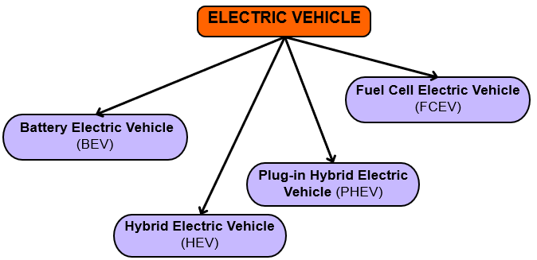

1.Battery Electric Vehicle (BEV): Powered by electric batteries, no internal combustion (IC) engine. Components: battery pack, electric motor(s), inverter, control module, drive train, charge port. Operation: The battery powers the electric motor, acts as an alternator during braking, and recharges the battery.

2.Hybrid Electric Vehicle (HEV): Combines IC engine and electric motor, battery charged through regenerative braking. Two types: Mild Hybrid Electric Vehicles (MHEVs) and Full Hybrid Electric Vehicles (FHEVs). Components: IC engine, electric motor(s), battery pack, inverter, control module, drive train, fuel tank, charge port. Operation: IC engine primary, electric motor assists for extended range.

3.Plug-in Hybrid Electric Vehicle (PHEV): Extended HEV with a chargeable battery, operates in all-electric and hybrid modes. Components: IC engine, electric motor(s), battery pack, inverter, control module, drive train, fuel tank, charge port, exhaust system. Operation: Electric motor drives until battery depleted, IC engine takes over, rechargeable via grid, regenerative braking, or IC engine.

4.Fuel Cell Electric Vehicle (FCEV): Uses fuel cell technology, generates electricity from hydrogen. Components: battery pack, electric motor(s), inverter, control module, drive train, fuel cell stack, fuel tank. Operation: Hydrogen converted to electricity via fuel cell stack, charges battery pack, powers electric motor(s) for propulsion.

Global Market Analysis

The global electric vehicle market is valued at USD 384.65 billion in 2022, forecasted to surge from USD 500.48 billion in 2023 to USD 1,579.10 billion by 2030. Anticipating a robust Compound Annual Growth Rate (CAGR) of 17.8% from 2023-2030, the market reflects accelerating adoption and investment in electric mobility.

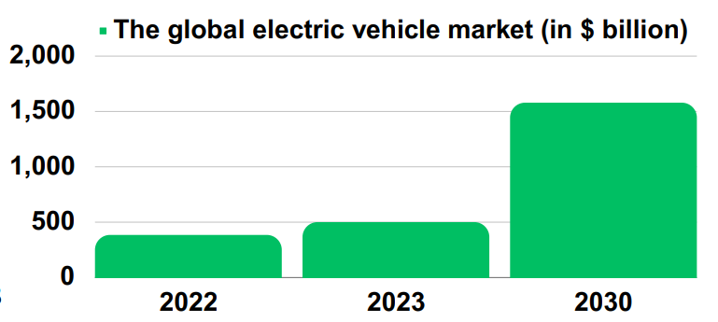

TOP MARKET PLAYERS OF EV MARKET

1. BYD 2. Tesla

3. Volkswagen 4. Nissan

5. BMW

Who Leads the Charge Towards Electric Mobility

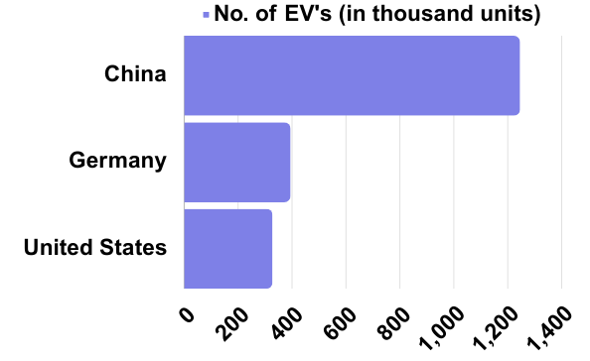

China tops global plug-in car numbers, owning 20.41 million units as of December 2023, almost half of the global fleet.

By 2026, over 50% of China's new passenger vehicle sales are projected to be electric.

(BEV) Battery Electric Vehicle Market

In 2021, the global ratio of Battery Electric Vehicles (BEVs) to Plug-in Hybrid Electric Vehicles (PHEVs) was 71:29. The BEV market exceeded USD 300 billion in 2022, poised for a 15% CAGR from 2023 to 2032. This growth is fueled by stringent global regulations addressing emissions from fossil-fuel-powered vehicles.

WHY ARE BEV’S PREFERRED?

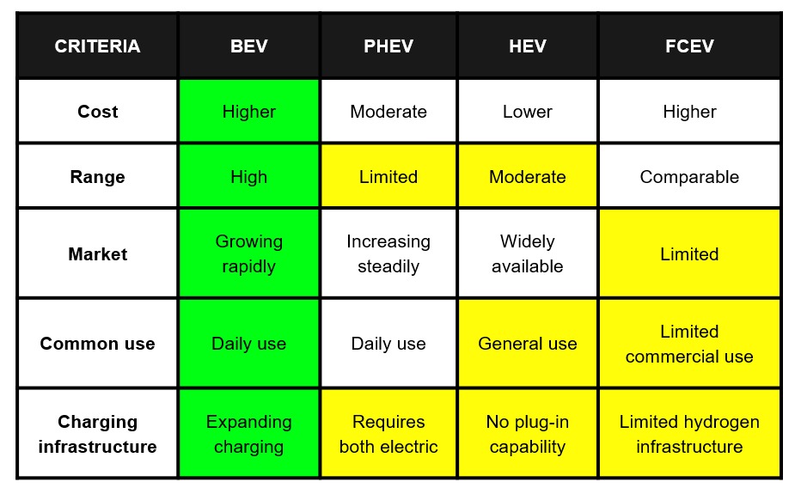

Jeevan Foundry, a leading global casting industry player, can enter the Electric Vehicle (EV) sector by strategically employing High-Pressure Die Casting (HPDC). Leveraging its casting expertise, Jeevan Foundry can contribute to the EV industry, fostering sustainability and aligning with the growing demand for advanced casting technologies in the electric mobility sector.

Career Alternatives for Mr. Sameer in the EV Sector

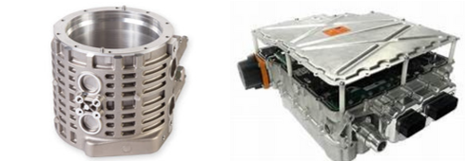

HOUSINGS FOR BATTERIES, MOTORS & INVERTER

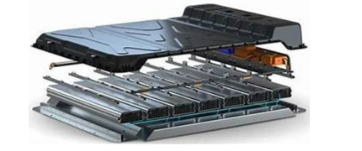EV HOUSING EQUIPMENTS

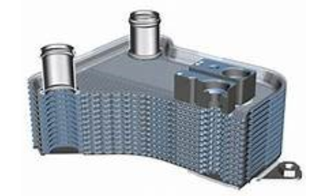 HEAT EXCHANGERS AND COOLING FINS TO ENSURE EFFICIENT THERMAL MANAGEMENT WITHIN EV SYSTEMS.

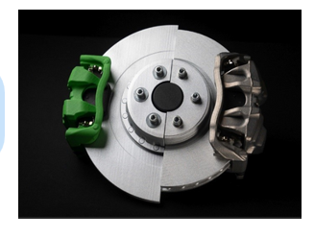 REGENERATIVE BRAKING & SUSPENSION SYSTEMS

Aluminum vs Cast Iron: Unveiling Preference

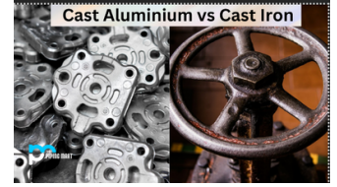

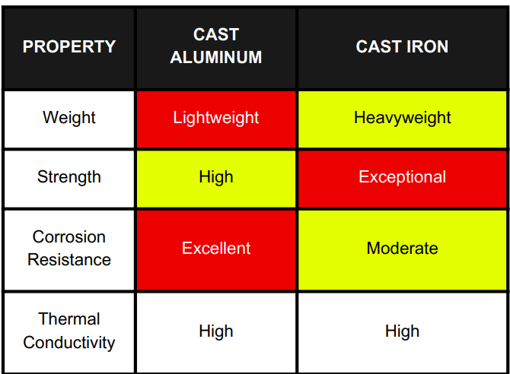

In line with the Paris Agreement's sustainability goals, Mr. Sameer should prefer aluminum over cast iron. Aluminum's lightweight, high-temperature resistance, and corrosion resistance align with eco-friendly initiatives, making it ideal for renewable alternatives, promoting energy efficiency and reducing environmental impact in industrial applications.

STRATEGIC TRANSITION TOWARDS ALUMINUM

**Stage 1: Research and Planning** In the initial phase, Mr. Sameer should conduct a thorough market analysis to assess the demand for aluminum components in the renewable energy sector. Identifying specific components and evaluating the High-Pressure Die Casting (HPDC) facility's capabilities are crucial for aligning with market needs.

**Stage 2: Product Development** Moving forward, Mr. Sameer should prioritize prototype development, creating test versions of aluminum components, and collaborating with renewable energy manufacturers for customized designs meeting industry requirements.

**Stage 3: Pilot Production** The third stage involves the commencement of small-scale production, allowing for gradual improvements based on user feedback. Implementing stringent quality control measures and obtaining necessary certifications are vital steps during pilot production.

**Stage 4: Market Expansion** As the market presence grows, Mr. Sameer should diversify the range of aluminum components and explore opportunities in new sectors. Emphasizing the environmental benefits of aluminum and building a reliable brand are crucial for market and brand development.

**Stage 5: Full-scale Production** In this stage, Mr. Sameer can strategically scale up production based on increasing demand. Continuous improvement of manufacturing processes and staying updated on technological advancements should be a priority.

**Stage 6: Industry Leadership** Mr. Sameer's company excels in aluminum casting for renewable energy, driven by R&D investments and strategic partnerships.

Conclusion

* **Strategic Global Market Focus:** Jeevan Foundry Ltd. wisely opts to stay connected with the global IC engine market, leveraging existing opportunities in the evolving automotive sector without hastily embracing major changes.
* **Specialization in High-Pressure Aluminum Die Casting:** The company's key emphasis on high-pressure aluminum die casting aligns seamlessly with the rising trends in electric vehicles (EVs) and hybrids. This strategic move positions Jeevan Foundry in accordance with global environmental goals outlined in the Paris Agreement.
* **Gradual Technological Adoption:** Mr. Sameer's leadership advocates for the strategic and gradual adoption of new technologies. This approach allows Jeevan Foundry to maintain its strength in the metal casting industry while navigating the industry's evolution.
* **Analytical Step-by-Step Transition:** A step-by-step transition, informed by thorough market analysis, ensures a smooth evolution. By understanding market trends and aligning transition stages with the company's strengths, Jeevan Foundry can adapt effectively.
* **Informed Decision-Making for Competitive Edge:** In-depth market analysis is crucial at each stage, providing Jeevan Foundry with a competitive edge. Well-informed decisions enable effective adaptation to the changing dynamics of the metal casting industry.
* **Alignment with Government Initiatives:** Actively aligning with government recommendations and initiatives positions the company as a responsible and compliant player in the industry. Staying informed about changing regulations and market trends is essential.
* **Sustainable Market Adaptation:** Jeevan Foundry adapts to the growing demand for EVs, hybrids, and CNG casting, ensuring sustainability, regulatory compliance, and portraying itself as a responsible industry player. Embracing eco-friendly options positions the company for government incentives, reinforcing its commitment to sustainability.

In conclusion, the strategic combination of global market focus,

Gradual adoption, and informed decision-making equips Jeevan Foundry Ltd. to navigate the evolving global metal casting industry confidently and resiliently.